Assignment 3.2 – 2NF

Shane Hingtgen

3/25/23

Bellevue University

|  |  |  |
| --- | --- | --- |
| publisher_name | author_last_name | book_name |
| Picador | Punke | The Revenant |
| William Morrow | Tolkien | The Lord of the Rings |
|  |  |  |

|  |  |  |
| --- | --- | --- |
| publisher_name | publisher_code | publisher_address |
| Picador | 12345 | 16365 James Madison Highway Gordonsville, VA 22942 |
| William Morrow | 56789 | 123 st Manhattan, New York  10451 |

|  |  |  |
| --- | --- | --- |
| book_name | book_isbn | book_price |
| The Revanant | 0786710276 | 46.94 |
| The Lord of the Rings | 9780544003415 | 24.99 |

|  |  |  |  |
| --- | --- | --- | --- |
| author_last_name | author_first_name | author_phone | author_email |
| Punke | Michael | 123-456-7890 | michaelpunke@email.com |
| Tolkien | J.R.R. | 789-1011-1213 | tolkien@email.com |

Publisher can have many authors

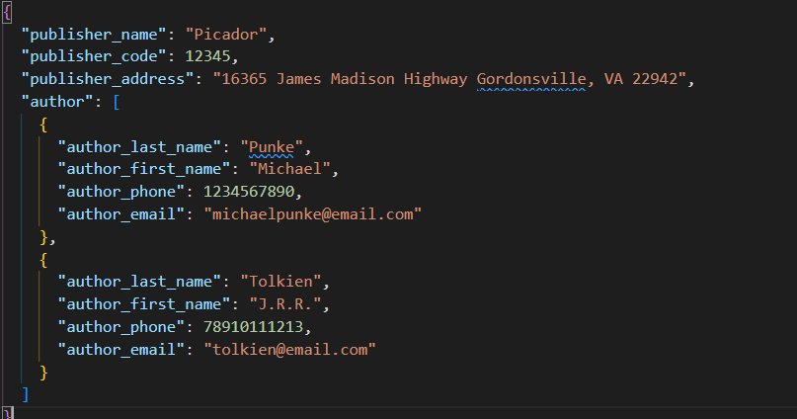

Author can have many books

Book can have a publisher

